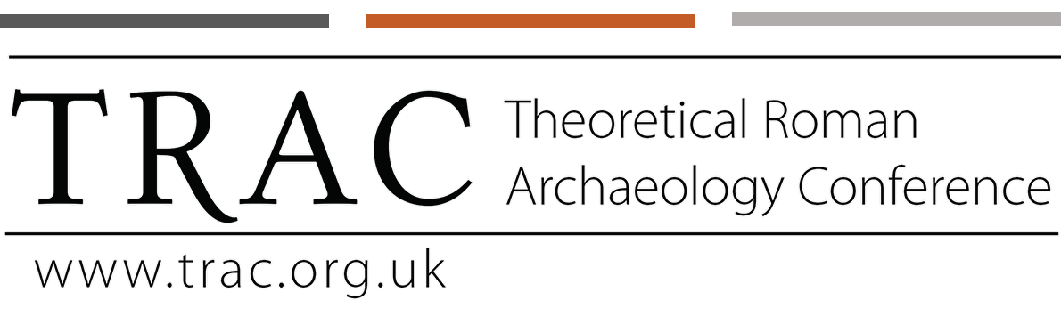

TRAC is pleased to announce our new 2020–2021 webinar series. All webinars will take place Tuesdays at 17:00 (UK Time) over Zoom. To register for a lecture, please follow the links provided below. Further details can also be found at trac.ork.uk.

November 17

Dr. Tomáš Glomb - The popularity of Asclepius in times of the Antonine and Cyprian plague: A quantitative approach

Register

December 1

Jessica Venner - Supply and Demand: Rise of the ‘Opportunistic Garden’ in Mid-First Century AD Pompeii

Register

December 15

Jordon Houston - Exotics for Entertainment: A Reconstruction

Register

January 5

Arnau Lario Devesa - Connecting the past. The application of Network Science in the study of Roman amphorae

Register

January 19

Dr. Francesca Fulminante - Infancy and Childhood in Pre-Roman and Roman Italy (1000 BC - 100 AD): data and perspectives to inform current polity in health and education

Register

February 2

Giuseppina Marano - Another “face of God”. The representation of the God-Altar in the Near-Eastern Roman Era between Onomastics and Archaeology

Register

February 16

Lindsey Mazurek - Deterritorializing Isis: Egyptian Religion and Globalization in Roman Macedonia

Register

March 2

Marta Alberti - Public archaeology of the Roman Frontier- from diggers to volunteers on Hadrian’s Wall and beyond

Register

March 16

Dr. ﻿Benjamin O. Bassett - ‘Romanization’, ‘Globalization’ and problems of acculturation in Roman Egypt: archaeological evidence from the Dakhleh Oasis

Register

March 30

Dr. J. Troy Samuels ﻿et al. ﻿- Reimagining Urban Success: Rhythms of activity at Gabii, Italy, 800 BC - AD 600

Register

April 13

Goran Đurđević - What is reflection? Mirrors and reflection in the global antiquities: comparison between Roman and Qin – Han Empire

Register

April 27

Maria C. Monteleone - Introducing archaeo-hydraulics as an archaeological science: new perspectives into the study of water structures

Register

